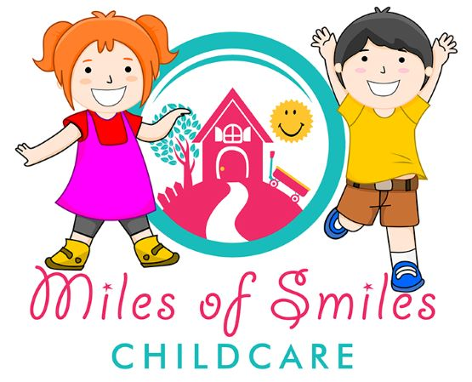PARENT / CAREGIVER AGREEMENT
On behalf of Miles of Smiles Childcare LTD, staff accepts partnership with _______________________________(parents) in the development of ______________________________(child).
The childcare undertakes to provide quality, responsible and nurturing childcare and is prepared to discuss any concerns with parents and is open to suggestions with regards to the childcare program.
In order to make a commitment to the child, the parent and the caregiver and the following decision to process, this contract must be signed by the caregiver and parent prior to the commencement of childcare.
- HOURS: -
Hours the child will be in the childcare __________a.m. to ____________p.m. if childcare time is more than 9 hours, please mention it clearly as there will be an extra charge. Please notify the childcare if you agreed upon time changed. In the case of late pick-up, the procedure will be : A charge of $1 a minute. If parents or alternate pick up person doesn’t show up till 6:30 p.m. staff will contact Ministry for children and family @604-660-8180.
- FEES: -
- To pay the monthly fee of $________________ on the 1st day of each month and to keep our account in good standing. If you accept a space and register but withdraw before your child start childcare, you will be responsible for a 1-month fee. To pay the full monthly fee as stated above regardless of attendance. In the case of a child’s absence or parent vacation, fees will remain same. Only by paying the monthly fee, the space will be reserved for your child.
- When it is time to leave Miles Of Smiles Childcare, or any change in your child’s space (full time to part time or part time to full time) a minimum of One month (1st day of month) notice will be required.
- If you are taking part time space, we won’t be able to swap your days for any reasons (sickness, vacation and emergency) as one full time space is shared by 2 children and part time are fixed.
- Upon registration, a non-refundable $150 fee will be charged as registration fee. For NSF cheque $25 will be charged.

- ILLNESS OR EMERGENCY OF CAREGIVER: -
In case of caregiver illness or emergency, childcare will attempt to make arrangements to hire a substitute to replace the caregiver. There will no rebate or prorating of monthly fees in the event of caregiver absence due to sickness or emergency as the childcare is in operation with a substitute.

- HOLIDAYS :-
Caregiver may take few days of vacation during which time usual monthly fees remain payable as a substitute will be hired to operate the facility.
In the case of parent’s holiday or temporary absence of the child, fees will be paid as usual as the space is reserved for your child.
Miles of Smiles childcare will be closed on all statutory holidays and 1 week in December for Christmas.

- DROP OFF AND PICK UP: -
The child will be released in the presence of the caregiver or authorised substitute to a parent. The parent shall notify childcare staff if the child is to be picked by an unauthorized person (an individual not indicated on the registration form). A person will be required to show 2 piece of picture ID and a written note from the parent. Please inform staff if your child is not attending any day or coming late.
- CLOTHING/BLANKET/BED SHEET/DIAPERS: -
- Parents will provide extra clothes, outdoor clothing, blanket, bed sheet, diapers, wipes, bum cream, indoor shoes/slippers, as well as lunch and milk/formula.
- Childcare will provide healthy morning and afternoon snack in case child forgets to bring any.
- Miles of Smiles childcare is peanut and junk food free zone.

- CONSENT FORM: -
- Use all play equipment’s: - ____________________________________
- Photograph for childcare purpose: - ______________________________
- Release of information to Licensing Officer: - _______________________
- Sunscreen, Diaper Cream or Lotion: - _______________________________
- Refundable deposit:- _______________________________________________

- ACCESS TO MEDICAL ATTENTION :-
I ______________________________________________give permission to centre staff to immediately access, medical attention for my child _____________________________.
This may include ambulance, care service, emergency ward/clinic. The centre staff will proceed with medical attention with the advice of the attending physician until the parent is contacted. While as parents/guardian, I Understand that reasonably precaution to ensure my child’s safety will be taken.
I also realise that accident may happen and by signing, I release Miles of Smiles childcare ltd and it staff from liability in case of an accident at Childcare. I also give consent for medical treatment for my child deemed necessary in the event of emergency. For this medical treatment service, I agree to reimburse Miles of Smiles Childcare for any cost that may incur as a result. (consent is relevant for the duration of your child’s enrollment).
MILES OF SMILES CHILDCARE HAS A RIGHT TO CHANGE THEIR POLICIES FOR THE BENEFIT OF CHILDREN AND PROGRAM. PARENT WILL BE NOTIFIED AHEAD OF TIME.
I/we have read and understand the above policies:-
Parent/guardian____________________________________ Date ______________________________________
Caregiver_____________________________________________ Date of acceptance_______________________

